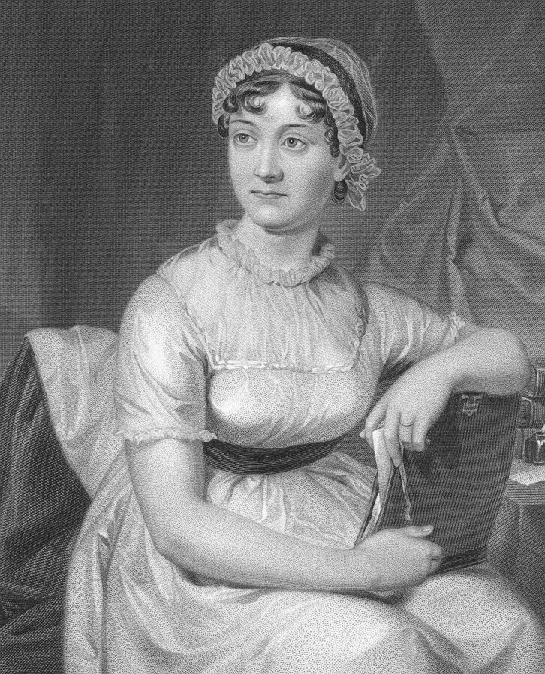 Jane Austen

Books to read

About Jane

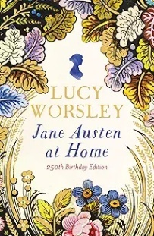

# Jane Austen A life Jane Austen at Home: A Biography

by Claire Tomlin by Lucy Worsley

Novels about her life

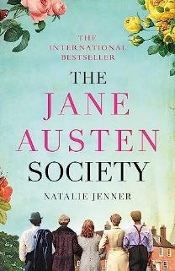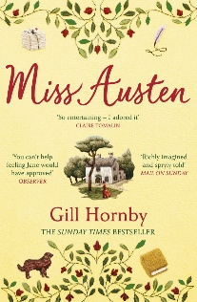Miss Austen The Jane Austen Society

By Gill Hornby by Natalie Jenner

You may not realise that Jane wrote

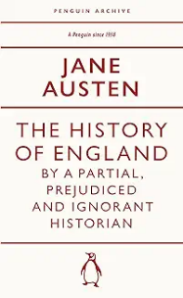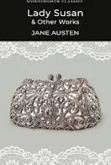The History of England Lady Susan and other works

By a partial, prejudiced

And ignorant historian

Modern and alternative versions of Jane Austen books

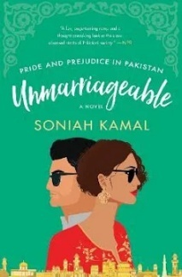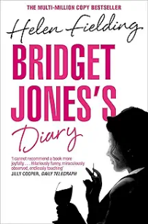

Bridget Jones’s Diary Unmarriageable

by Helen Fielding by Soniah Kamal

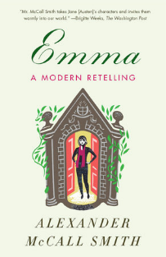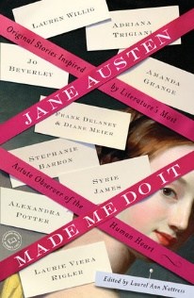Jane Austen Made me Emma A Modern Retelling

Do It By Alexander McCall Smith

by Adriana Trigiani,

Jo Beverley, Margaret

Sullivan and Janet

Mullany

Unusual books

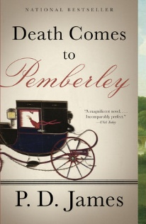

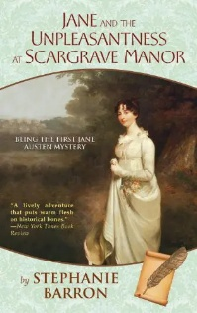Death Comes to Jane and the Unpleasantness

Pemberley at Scargrave Manor: being the

By P D.James First Jane Austen Mystery:

1 (Being a Jane Austen Mystery)

By Stephanie Barron

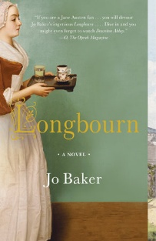

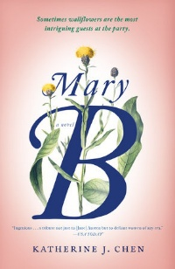Longbourne Mary B

By Jo Baker By Katherine J Chen

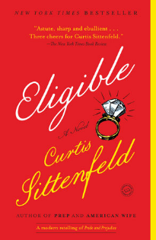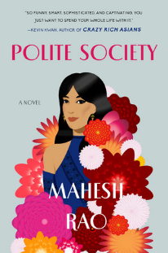Eligible Polite Society

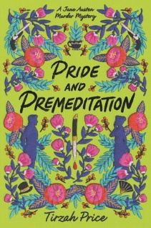By Curtis Siteenfeld By Mahesh Rao

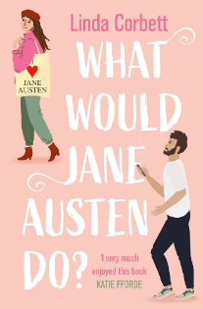

Pride and Premeditation What Would Jane Austen Do?

By Tirzah Price By Linda Corbett